LeadingAge Oregon
Leadership Academy

Class of 2018-2019
Information and Application
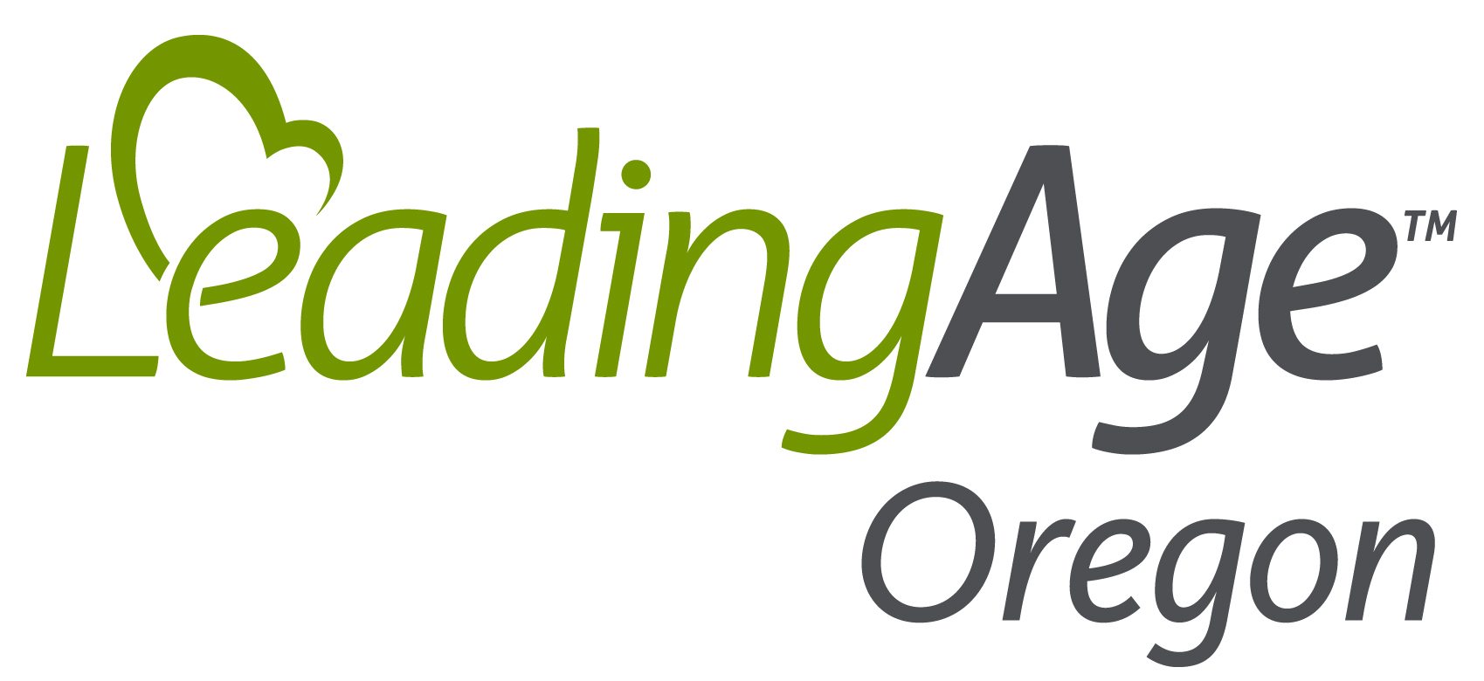
Are you or a member of your staff thinking about applying for the LeadingAge Oregon Leadership Academy class of 2018-2019?

You might be interested in hearing what some members of previous classes have to say about the program:

“Meeting and spending time with my peers in the industry has been a welcome and refreshing change to my daily routines. I have learned a lot from the team and really appreciate their friendship.”

“I have a very strong belief that all elderly people deserve to be treated with kindness, dignity, and respect. I am a very reserved and quiet person and don’t always communicate my beliefs and/or thoughts well. Taking the leadership program has really opened my eyes to comfortable ways to communicate and challenged me to step out of my comfort zone!”

“The leadership materials and tools we have been given are invaluable and really helpful for self-reflection and personal growth. I have applied what I have learned at work and it has led to some great outcomes.”

“I have taken so much from the class on how to lead and how to value each and every person I work with.”

“The networking has been fabulous. I used to feel like I was on my own island and I found that there is a whole world of us out there!”

“I am so grateful for the opportunity to network with this wonderful group of people! I have gained so much from everyone!”

expanding the world of possibilities for aging in Oregon
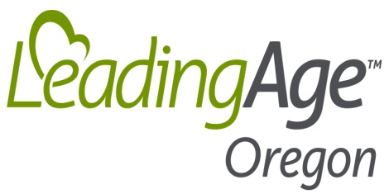
May 16, 2018
Dear LeadingAge Oregon Leader,
Our association’s leadership program – known as the LeadingAge Oregon Leadership Academy – is in the middle of its ninth year, and it continues to be more exciting and enriching than we ever anticipated!
This year’s Leadership Fellows, teamed with three Leadership mentors, have spent the last several months learning together, examining the qualities of exceptional leaders, and developing bonds with each other that will only strengthen throughout the years. We are confident that the work they are doing this year will benefit their organizations, LeadingAge Oregon and aging services in Oregon for years to come!
Now it’s time to begin our search for the LeadingAge Leadership Academy class of 2018-2019. Please look around your organization and consider who would benefit from this special program, which was designed to identify and develop leaders for LeadingAge Oregon member organizations, the aging services field and the LeadingAge Oregon board.
Enclosed is a description of the program and an application form. The kick-off event will be September 26, 2018 at the LeadingAge Oregon Fall Leadership Conference at the Hood River Inn.
Participants in this program can be staff working at any level in your organization. Current and past participants include individuals new to the field as well as veterans with 30 years in aging services! We have developed a simple application for the participant to complete. In addition, there is a place for you to provide your support of this individual. There will be a $1,500 tuition fee for the program for provider members, $2,000 for business members (in addition to some other costs, see more detail in application).
Please note: We will offer up to one Leadership Academy scholarship that will cover tuition and fees. If your organization has never sponsored a Leadership Academy participant, or is unable to do so this year, and you have a staff member who would be ideal for the Academy experience, please consider having them apply!
Please take this opportunity to identify someone in your organization who may be interested in participating and forward them the application form. Interested applicants should complete and e-mail an electronic copy of the attached application and their resume by July 31.
Please be sure to contact me personally if you need more information.
Thank you.
Ruth Gulyas, CEO

What is Leadership Alliance?
Leadership Alliance offers a challenging and engaging year-long learning experience, designed to help aging services professionals accelerate their leadership development so they are better equipped to serve our field. Leadership Alliance is for individuals in the aging services field who are in the early and middle stages of their careers. It is for people who want to know more about the Alliance and the field of aging services while also looking to enhance their leadership skills and participate, network and develop their career.

It is limited to 8-10 participants chosen through a formal application process to secure commitment of participants and the support of their supervisor/organization.

Why Leadership Alliance?
Leadership Alliance enhances personal and professional growth while participants gain leadership skills as well as awareness of current issues. During Leadership Alliance, participants will examine the traits of successful leaders, work on their own leadership development, learn more about the field of aging services, and establish strong bonds with their peers in the field.

What does Leadership Alliance consist of?
The Leadership Alliance Leadership Committee includes our facilitator, consultant Bill Zipp (www.billzipp.com) as well as individuals who have completed Leadership AAHSA or Leadership Alliance. The Committee plans/directs the Leadership Alliance program, which will include the following events for 2011-2012 (and perhaps others as chosen by the class):

EVENTS:
- August Webinar: LPI (Leadership Practices Inventory) Kickoff

What is the LeadingAge Oregon Leadership Academy?
The LeadingAge Oregon Leadership Academy offers a challenging and engaging year-long learning experience, designed to help aging services professionals accelerate their leadership development so they are better equipped to serve our field. The Leadership Academy is for individuals in the aging services field who are in the early and middle stages of their careers. It is for people who want to know more about LeadingAge Oregon and the field of aging services while also looking to enhance their leadership skills and participate, network and develop their career. The program probably benefits most those individuals who supervise employees, but individuals with any job description within aging services will benefit from learning how to demonstrate leadership skills with their peers, supervisors, residents, clients and family members.

The program is limited to 9-11 participants chosen through a formal application process to secure commitment of participants and the support of their supervisor/organization.

Why LeadingAge Oregon Leadership Academy?
The Leadership Academy enhances personal and professional growth while participants gain leadership skills as well as awareness of current issues. Through the Leadership Academy, participants will examine the traits of successful leaders, work on a chosen project to strengthen targeted leadership skills, learn more about the field of aging services, and establish strong bonds with their peers in the field.

What does the Leadership Academy consist of?
The Leadership Academy Planning Committee includes our facilitator, consultant Bill Zipp (www.billzipp.com), as well as individuals who have completed the LeadingAge Leadership Academy or the LeadingAge Oregon Leadership Academy. The Committee plans/directs the Leadership Academy program, which will include the following events for 2018-2019 (and others as chosen by the class. The class meets roughly once per month):

EVENTS:
Note: This year we had one of our site visits at a LeadingAge Washington member organization, so applicants will want to be prepared for that possibility again this year.

1. Fall Leadership Conference – September 26-28, 2018 – Hood River Inn, Newport
- Leadership Academy participants, mentors and our Leadership Academy facilitator will participate in special programs and events throughout the conference.

2. October/November: 1 on 1 LPI De-Brief meetings

3. Early December: Leadership Academy evening/dinner meeting and discussion

4. Late January: Day-long site visit to LeadingAge Oregon or LeadingAge Washington member community
- Site visit includes in-depth interviews of staff, examination of organizational and leadership culture, as well as operational tour and discussion/de-brief

5. February: Group meeting/leadership discussion
6. Legislative Advocacy Day – April 3, 2019 at the Capitol, Hearing Room 50

7. April: 1 ½ Day-long site visit to LeadingAge Oregon or LeadingAge Washington member community
- Site visit includes in-depth interviews of staff, examination of organizational and leadership culture, as well as operational tour and discussion/de-brief

8. Annual Conference – May 14-17, 2019 – Eagle Crest Resort, Redmond
- Leadership Academy participants, mentors and our Leadership Academy facilitator will participate in special programs and events throughout the conference.

9. June: Group meeting/leadership discussion

10. August/September: Final Project Presentation and Dinner

11. Fall Leadership Conference – October 9-11, 2019 – Agate Beach Inn, Newport
- Recognition event for those completing program.

No matter what your role in the organization, the Leadership Academy may be for you. You can hear from experts on a variety of topics relevant to your career while sharing time with peers in various information settings. You’ll get a glimpse of how other organizations operate, maybe share an idea or two with them, and walk away recharged with ideas or new connections that can be fostered within your own organization.

Leadership Academy goals:
- Develop enriching events for the group to attend throughout the year;
- Give participants the opportunity to further develop targeted leadership skills and practices through a personal project
- Help LeadingAge Oregon members build stronger organizations;
- Develop programming to educate and promote personal leadership growth of participants;
- Give emerging leaders the opportunity to learn from the rich experience of long-time leaders in aging services
- Have the group self-sustain through building social capital in the field as well as succession planning for LeadingAge Oregon organizations;
- Expand our range of activities to meet the ongoing needs of the participants.

If I become a Leadership Academy Fellow:
The Leadership Academy will be what you make of it. If you make the most of the events and opportunities offered, you and your organization will be enriched. Leadership Academy membership is open to employees in current LeadingAge Oregon provider member organizations and Business Associate companies. If you are interested, an application form is attached. Be sure to contact LeadingAge Oregon if you have any questions.

2018-2019 LeadingAge Oregon Leadership Academy Application

LeadingAge Oregon Leadership Academy

The LeadingAge Oregon Leadership Academy offers a challenging and engaging year-long learning experience, designed to help aging services professionals accelerate their leadership development so they are better equipped to serve our field. It is limited to 9-11 participants chosen through an application process.

2018-2019 Learning Schedule

Chosen Leadership Fellows will participate in learning experiences that include attending and participating in the LeadingAge Oregon Fall Leadership Conference and Annual Conference, tours of member communities, work on their personal leadership projects, intimate conversations with aging services leaders and self-exploration of leadership styles through exercises and readings. The selected sites and dates for the 2018-2019 Leadership Academy class are as follows (note: Some changes/additions may be made at request of class):

September 26-28, 2018 | Fall Leadership Conference, Hood River Inn, Hood River
Oct/November 2018 | 1 on 1 LPI De-Brief meetings (scheduled individually) (approx. 1 hour)
December 2018 | Dinner meeting/discussion (3 hours)
Late January 2019 | Day-long site visit to LeadingAge Oregon/Washington member community
February 2019 | Group meeting/Leadership Discussion (2-3 hours)
April 3, 2019 | Legislative Advocacy Day, Capitol, Hearing Room 50, Salem
April 2019 | Group meeting/Leadership Discussion (2-3 hours)
May 14-17, 2019 | Annual Conference, Eagle Crest Resort, Redmond
June 2019 | Day-long site visit to LeadingAge Oregon/Washington member community
August/Sept 2019 | Final Project Presentation and Dinner (3 hours)
October 9-11, 2019 | Fall Leadership Conference, Agate Beach Inn, Newport

Eligibility

The program is available to anyone who works for a LeadingAge Oregon provider member or a Business Associate company, irrespective of clinical or managerial experience. It is far more important for potential Leadership Fellows to demonstrate deep leadership potential within their organizations than it is for them to carry specific job titles. However, we have recognized over the years that the staff who benefit most from the program are those who have some supervisory duties or are in a position that requires them to work with a variety of staff in a collaborative capacity.

A $1,500 tuition payment* is required from each Leadership Fellow’s provider organization. Tuition is $2,000 for staff from business member companies. In addition, the required 360° Leadership Practices Inventory ($199), lodging, travel expenses, and some meals are also paid by each Leadership Fellow’s organization or company (the costs incurred vary depending on the locations of the site visits which may be in Eastern/Southern Oregon or Washington State). Meals at conferences are provided on-site at no additional cost.

LeadingAge Oregon provides complimentary registrations for each Leadership Fellow to the first Fall Leadership Conference and the LeadingAge Oregon Annual Conference. Leadership Fellows will be responsible for regular conference fees for the 2019 Fall Leadership Conference.

Please note: LeadingAge Oregon will offer up to one Leadership Academy scholarship for 2018-2019 that will cover tuition and fees. Please see Scholarship Application addendum for additional information. If requesting a scholarship, the Leadership Application and Scholarship Application must be submitted at the same time.
Leadership Fellows will need access to a personal computer for regular e-mail contacts.

An application form follows. All application submissions will be reviewed to ultimately assemble a diverse class of Leadership Fellows (in terms of life experience, leadership roles, geography, type of organization as well as other unique characteristics). A committee of LeadingAge Oregon members and association staff will evaluate the applications to assure such diversity.

Submission Deadline

To ensure consideration, please type your responses directly into the Word-based application that follows, save the completed application and e-mail it (and Scholarship Application, if applicable) to Merry Killam at LeadingAge Oregon (mkillam@leadingageoregon.org) no later than July 31, 2018. Applicants will receive notification of their acceptance status by August 15, 2018. Questions may also be directed to Merry, PH: 503-684-3788, extension 303.

LeadingAge Oregon Leadership Academy Participant Application
Please complete this form electronically (on your computer).
We will not accept hand-written applications.

For the Potential Participant:

Name of Participant:

Name of LeadingAge Oregon provider or Business Associate member:

Participant work phone: Cell phone:

Email:

Position Title: Years in Position:

Years with current employer: Years in aging services field:

Please attach your resume and answer the following questions:

- Why are you interested in the program?

- What do you hope to gain from your participation in this program?

By submitting this application, I agree to participate in the LeadingAge Oregon Leadership Academy through active attendance and engaged participation.

Participant name: Date:

For the supervisor of the participant:

I agree that this employee is a good candidate for the Leadership Academy program. I will support my employee by:

- Paying $1,500 (provider members) and $2000 (business members) tuition and covering other costs ($199 for LPI, travel/lodging for conferences and out of town events, etc.) of the program as outlined above; OR assisting the employee to submit a scholarship application. (Please note that if a scholarship is awarded, the employing organization remains responsible for travel/lodging and occasional meal costs associated with conferences, site visits and other Leadership Academy meetings).

- Allowing time for him/her to attend the LeadingAge Oregon Fall Leadership Conference, the LeadingAge Oregon Annual Conference, Legislative Advocacy Day and additional meetings as outlined above;

- Checking in with him/her about his/her experience to ensure it is meaningful; and

- Allowing him/her opportunities to develop his/her skills in our organization.

(*Note: Tuition and fees are non-refundable once the Leadership program begins).

Please describe how this person has already demonstrated or shown the potential for leadership within your community or company, and within aging services?

In addition, I will participate in an evaluation to provide LeadingAge Oregon feedback about this program.

Name of supervisor completing this form:

Date:

Please save an electronic copy of this completed application and e-mail it and your resume (with scholarship application, if applicable) to Merry Killam at the LeadingAge Oregon office
(mkillam@leadingageoregon.org) no later than July 31, 2018

Please note: You will receive an e-mailed reply when your application is received. If you do not receive a reply, please check in with Merry at 503.684.3788.

